**SQL ASSIGNMENT - 1**

Creating table named **products**

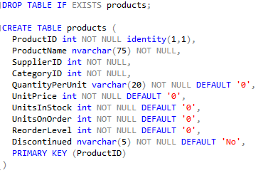

Inserting data into Created Table

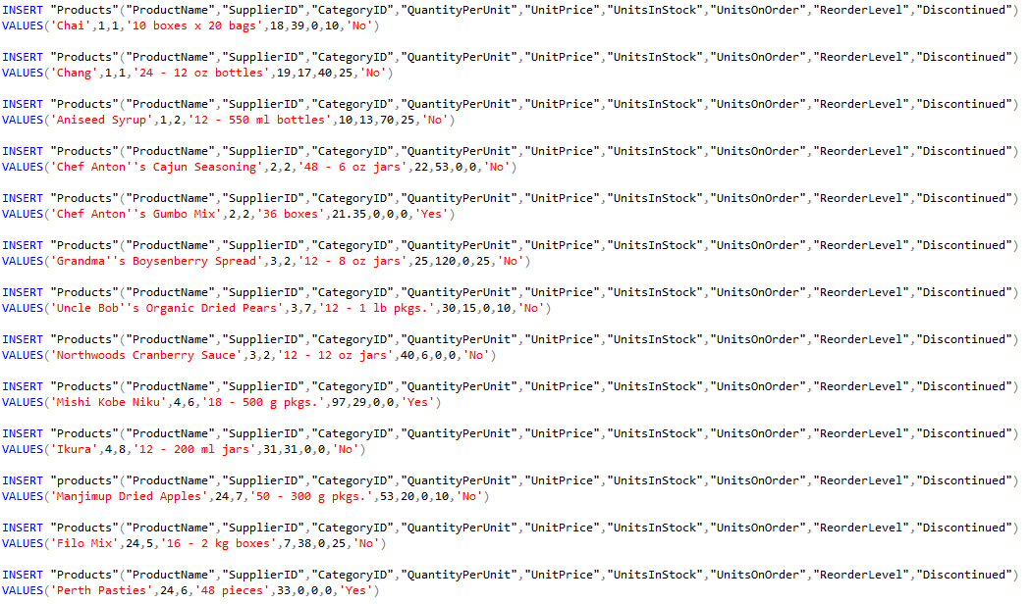

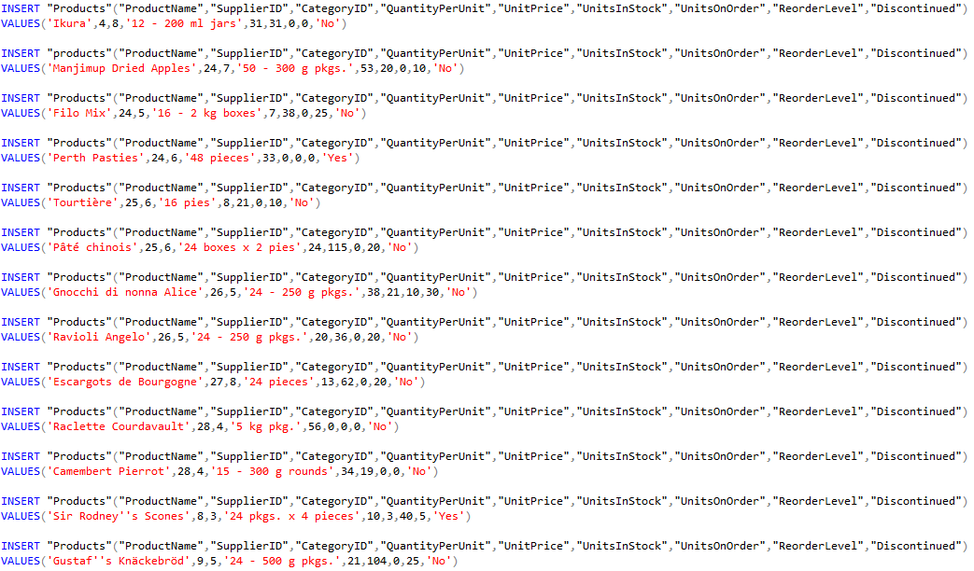

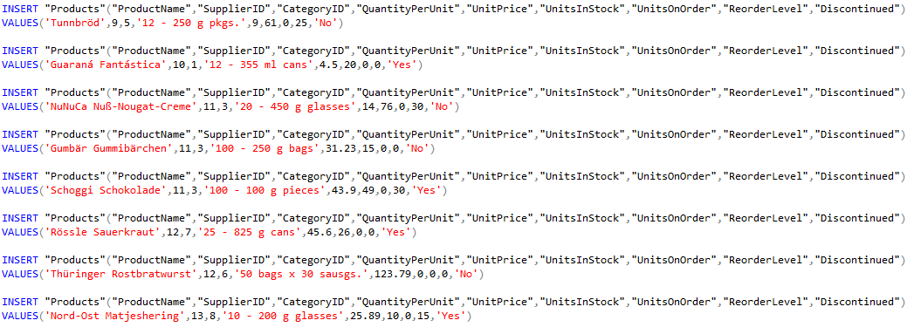

Viewing the Inserted Data:

→ SELECT * FROM products

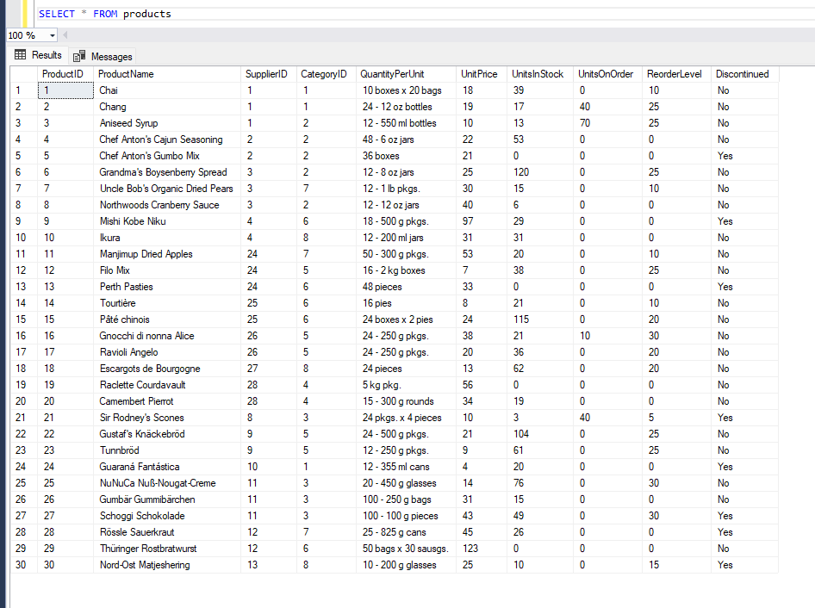

**1. Write a query to get a Product list (id, name, unit price) where current products cost less than $20.**

**→ SELECT productId, ProductName, UnitPrice FROM products WHERE Discontinued='No' AND UnitPrice < 20**

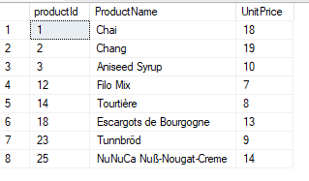

**2. Write a query to get Product list (id, name, unit price) where products cost between $15 and $25**

**SELECT productId, ProductName, UnitPrice FROM products WHERE UnitPrice BETWEEN 15 AND 25**

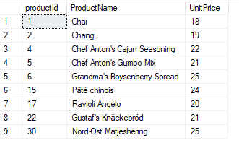

**3. Write a query to get Product list (name, unit price) of above average price**

**→ SELECT ProductName, UnitPrice FROM products WHERE UnitPrice > (SELECT AVG(UnitPrice) FROM products)**

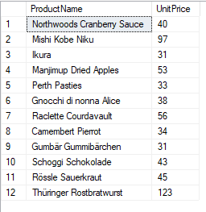

**4. Write a query to get Product list (name, unit price) of ten most expensive products**

**SELECT DISTINCT ProductName as Most_Ten_Expensive_Products, UnitPrice**

**FROM Products AS a**

**WHERE 10 >= (SELECT COUNT(DISTINCT UnitPrice)**

**FROM Products AS b**

**WHERE b.UnitPrice >= a.UnitPrice)**

**ORDER BY UnitPrice desc;**

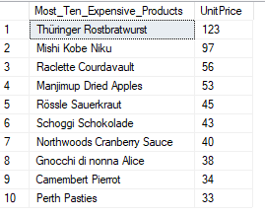

**5. Write a query to count current and discontinued products**

**SELECT (Count(ProductName)) AS CURRENT_PRODUCTS**

**FROM Products**

**GROUP BY Discontinued**

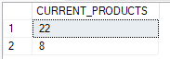

**6. Write a query to get Product list (name, units on order , units in stock) of stock is less than the quantity on order.**

**SELECT ProductName, UnitsOnOrder , UnitsInStock**

**FROM Products**

**WHERE (UnitsInStock < UnitsOnOrder) AND (Discontinued='No')**

